**POC 2: IT Set status to Action needed on Res Code Repair Not Possible (+ W1, W2 RO)**

**Functionality:**

Workflow “IT Set status to Action needed on Res Code Repair Not Possible (+ W1, W2 RO)” is created to update a field “Status” to “Action Needed” value if any of the below group of the condition is satisfied in the business rule/condition setup in the C4C tenant.

Below are some of the screens and Excel-sheet with Business rules:

**Technical Details:**

* Technical Flow

GET: C4C Ticket ODATA REQ

C4C: Ticket Save

Event Triggered

BTP/KYMA

KYMA/BTP Business Rules

PATCH: C4C Ticket ODATA REQ

**ODATA Service:**

*Test Tenant:* <https://my324697.crm.ondemand.com/>

*Event Name/Details:*

The event will be reconfigured, as of now “SAP_BTP_EXTENSION_KYMA” as a reference

*Event Payload Ref:*

Ex: in below Payload “00163EAB6A1F1EDC98AF7657E4D9BF21” is the Ticket Root Entity ID

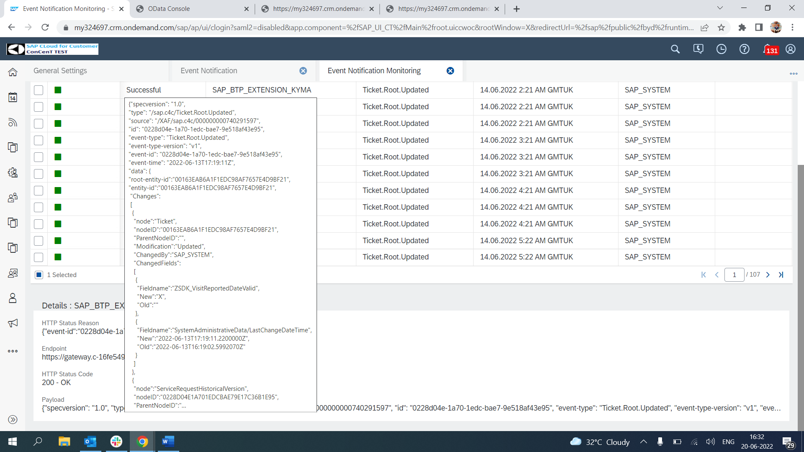

*GET Call:*

GET call is made to C4C tenant to get the details of the attributes which will be required for the Business Rule Configuration and against which conditions are compared and the following update is done back to C4C.

*Sample:*

<https://XXXXXX.crm.ondemand.com/sap/c4c/odata/cust/v1/srvtkt/ServiceRequestCollection(‘YYYYYYYYYYYYYYY’)?$expand=ServiceRequestUsedAddress>

XXXXX->Tenant ID

YYYY… ->Entity ID (Ticket Root Entity ID)

*For Above Ref Payload below is the URL Built:*

<https://my324697.crm.ondemand.com/sap/c4c/odata/cust/v1/srvtkt/ServiceRequestCollection('00163E2438E51EE881CF0881AD4008C1')?$expand=ServiceRequestUsedAddress>

*Attached Metadata/Get Request-Response:*



*Key Imp Attributes:*

|  |  |  |
| --- | --- | --- |
| **Sno** | **UI Name** | **Technical Name** |
| Attribute 1 | Country/Region | CountryText |
| Attribute 2 | Resolution Code | ResolutionCode_KUTText |
| Attribute 3 | Claim Status (SP) | LX_TKT_CLMSTS_KUT |
| Attribute 4 | Service Category ID | ServiceIssueCategoryID |
| Attribute 5 | Status | ServiceRequestUserLifeCycleStatusCodeText |
| Attribute 6 | Approval Status | ApprovalStatusCodeText |
| Attribute 7 | Resolution Category ID | ActivityServiceIssueCategoryID |

*PATCH Call:*

PATCH call is made back to the C4C Tenant to update the field “ServiceRequestUserLifeCycleStatusCode” with the specific value “Z6” – “Action Need” if the business rule condition is valid.

Postman collection file and user creds

